**Task 02_HomeTask_REST_Functional**

1. Verify the number of resources at each resource end point (6 marks)

• Endpoint: /posts

• Request **Type**: GET

• Base **URL**: https://jsonplaceholder.typicode.com

• Full **URL**: <https://jsonplaceholder.typicode.com/posts>

**Steps:**

* Send a GET request to /posts.
* Verify the response status code is 200.
* Count the number of items in the response body.

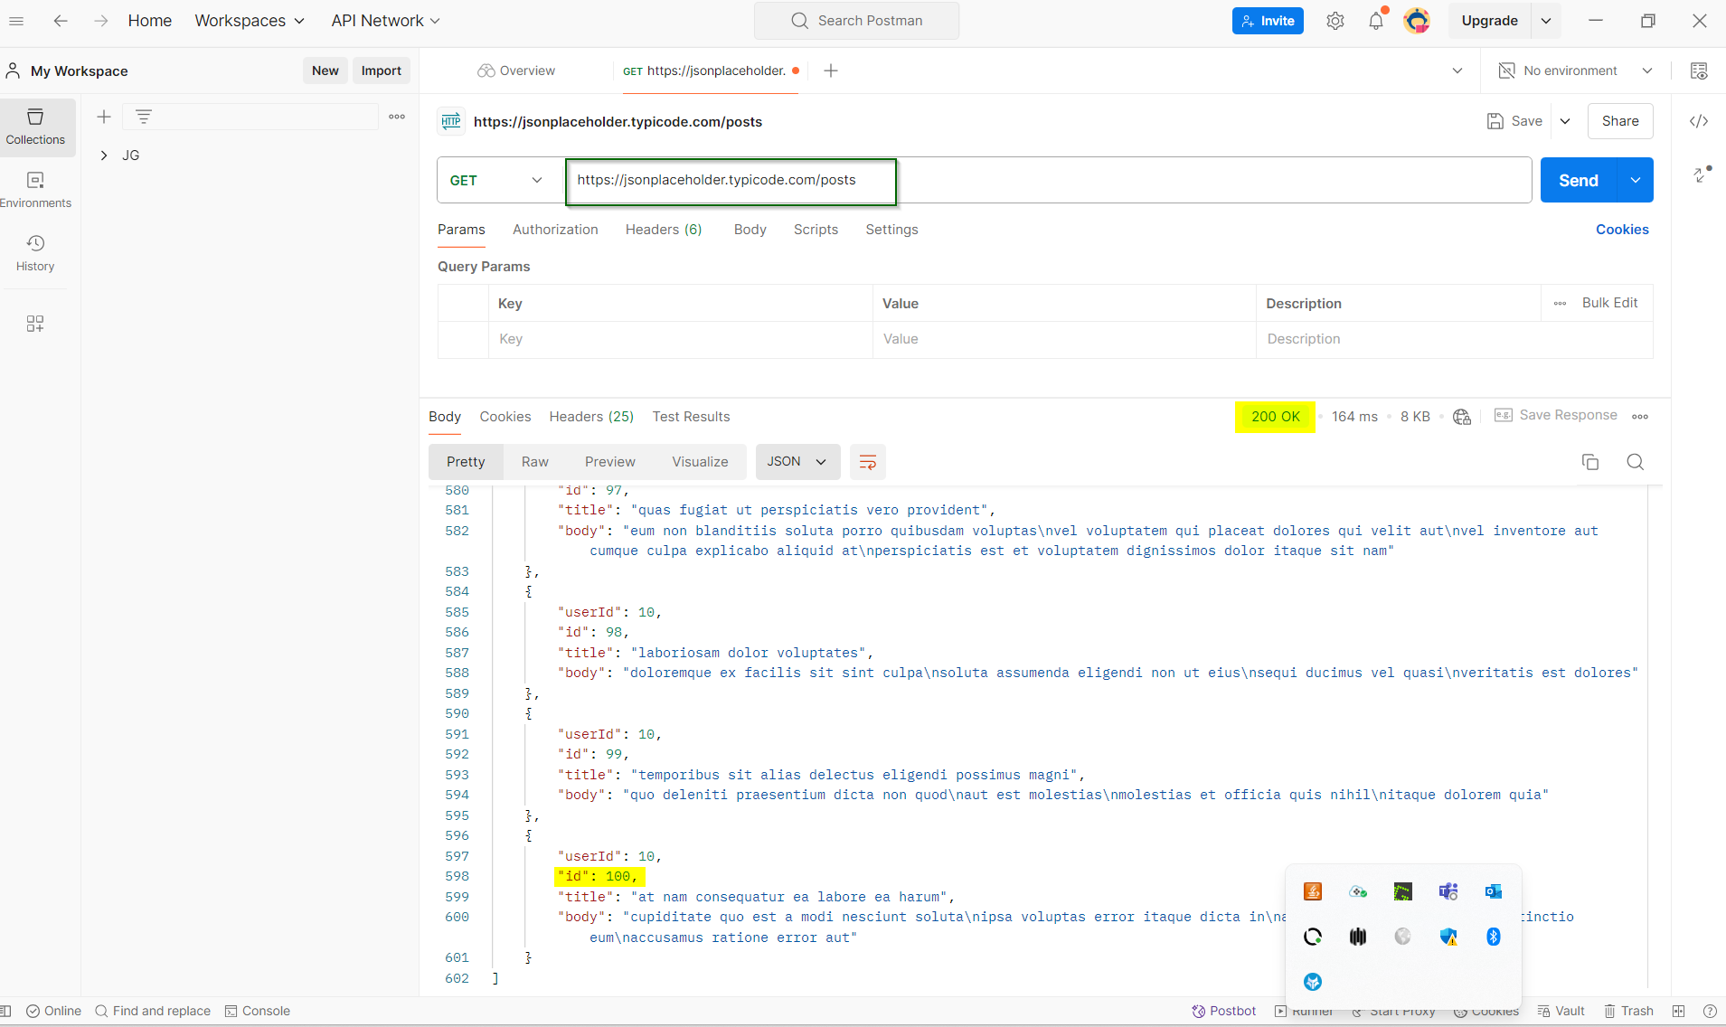

• Endpoint: /comments

• Request **Type**: GET

• Base **URL**: https://jsonplaceholder.typicode.com

• Full **URL**: https://jsonplaceholder.typicode.com/comments

**Steps:**

* Send a GET request to /comments.
* Verify the response status code is 200.
* Count the number of items in the response body.

• Endpoint: /albums

• Request **Type**: GET

• Base **URL**: https://jsonplaceholder.typicode.com

• Full **URL**: https://jsonplaceholder.typicode.com/albums

**Steps:**

* Send a GET request to /albums.
* Verify the response status code is 200.
* Count the number of items in the response body.

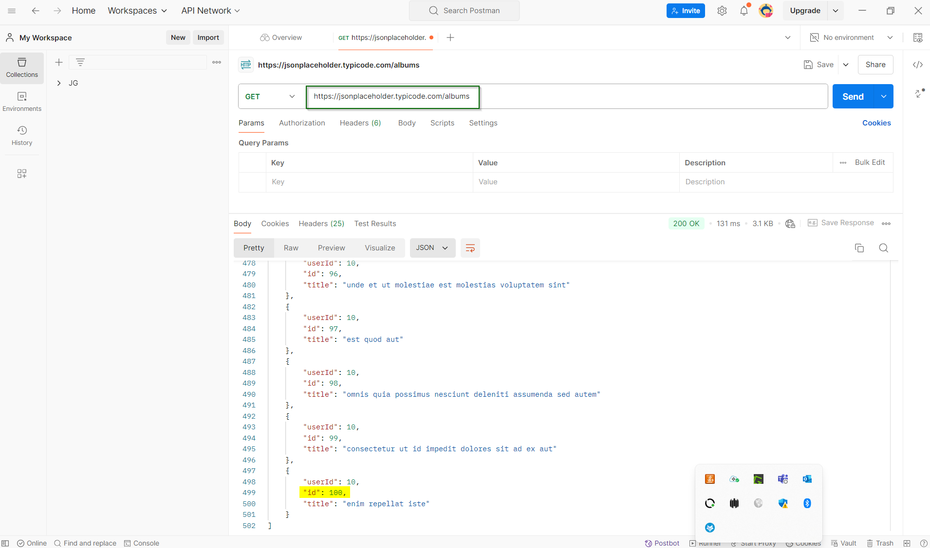

Endpoint: /photos

• Request **Type**: GET

• Base **URL**: https://jsonplaceholder.typicode.com

• Full **URL**: https://jsonplaceholder.typicode.com/photos

**Steps:**

* Send a GET request to /photos.
* Verify the response status code is 200.
* Count the number of items in the response body.

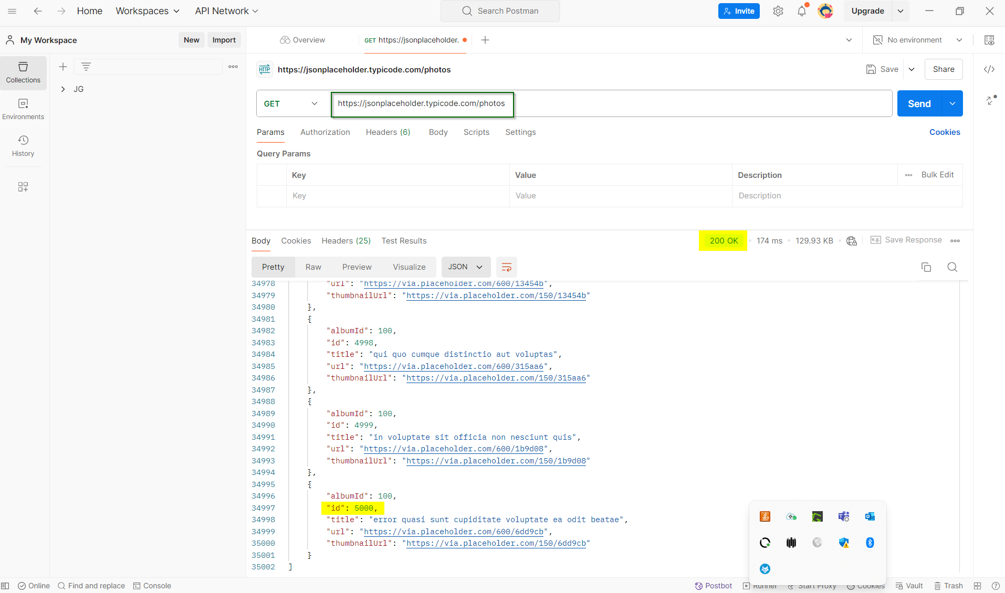

Endpoint: /todos

• Request **Type**: GET

• Base **URL**: https://jsonplaceholder.typicode.com

• Full **URL**: https://jsonplaceholder.typicode.com/todos

**Steps:**

* Send a GET request to /todos.
* Verify the response status code is 200.
* Count the number of items in the response body.

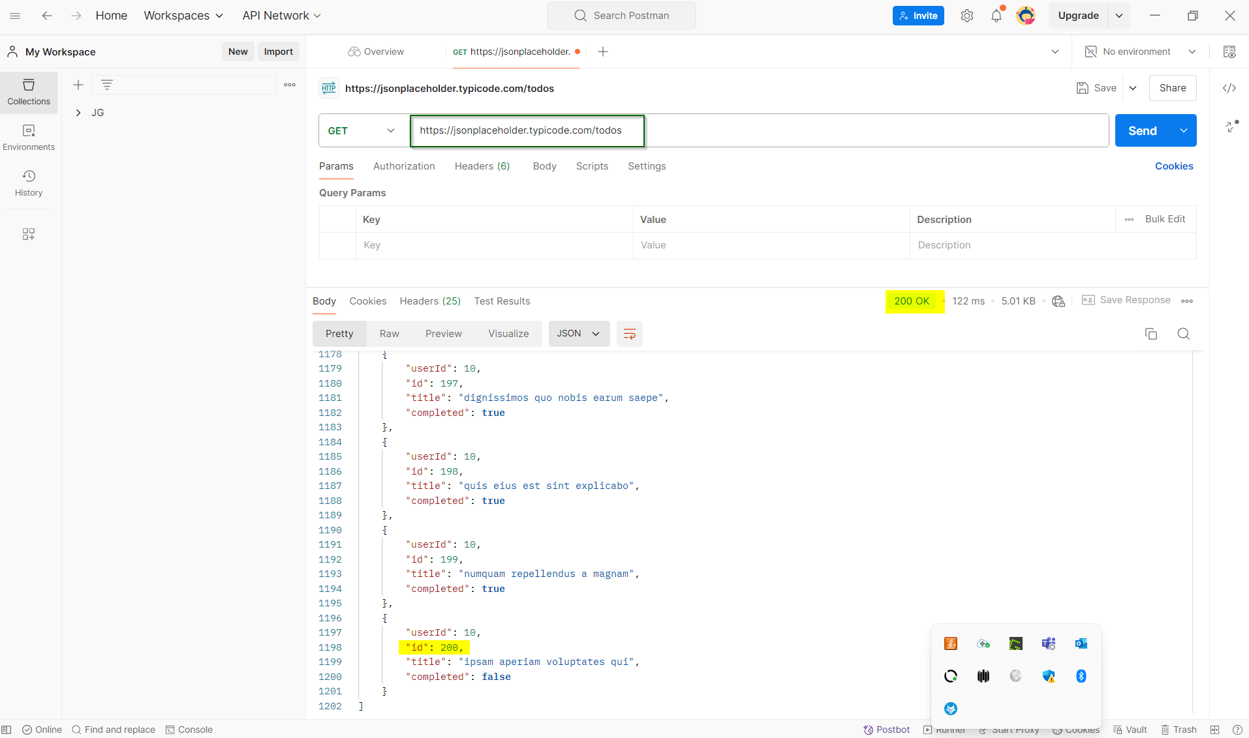

Endpoint: /users

• Request **Type**: GET

• Base **URL**: https://jsonplaceholder.typicode.com

• Full **URL**: https://jsonplaceholder.typicode.com/users

**Steps:**

* Send a GET request to /users.
* Verify the response status code is 200.
* Count the number of items in the response body.

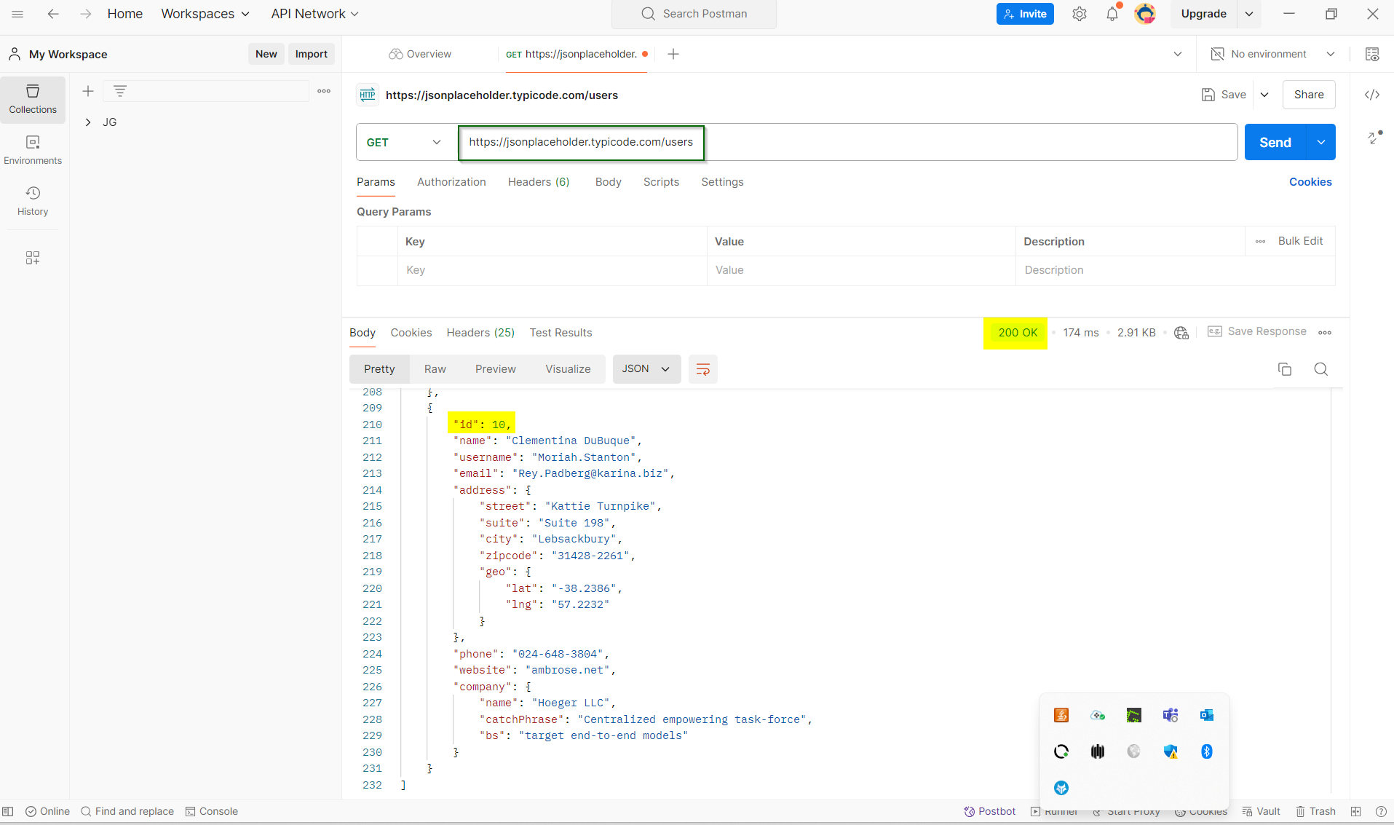

1. **For each type of resource Get a specific resource data (6 marks). verify the response code. Verify the response body.**

* **Request Type**: GET
* **Example URL**: https://jsonplaceholder.typicode.com/posts/1 (for the first post)

**Steps:**

* Send a GET request to retrieve a specific resource.
* Verify the response status code is 200.
* Verify the response body contains the expected data.

* **Request Type**: GET
* **Example URL**: https://jsonplaceholder.typicode.com/comments/500

**Steps:**

* Send a GET request to retrieve a specific resource.
* Verify the response status code is 200.
* Verify the response body contains the expected data.

* **Request Type**: GET
* **Example URL**: https://jsonplaceholder.typicode.com/albums/21

**Steps:**

* Send a GET request to retrieve a specific resource.
* Verify the response status code is 200.
* Verify the response body contains the expected data.

* **Request Type**: GET
* **Example URL**: https://jsonplaceholder.typicode.com/photos/999

**Steps:**

* Send a GET request to retrieve a specific resource.
* Verify the response status code is 200.
* Verify the response body contains the expected data.

* **Request Type**: GET
* **Example URL**: https://jsonplaceholder.typicode.com/todos/100

**Steps:**

* Send a GET request to retrieve a specific resource.
* Verify the response status code is 200.
* Verify the response body contains the expected data.

* **Request Type**: GET
* **Example URL**: https://jsonplaceholder.typicode.com/users/9

**Steps:**

* Send a GET request to retrieve a specific resource.
* Verify the response status code is 200.
* Verify the response body contains the expected data.

**b. Modify a specific resource data (6 marks). verify the response code. Verify the response body.**

* **Request Type**: PATCH
* **Example URL**: https://jsonplaceholder.typicode.com/posts/1

**Steps:**

* Send a PATCH request with updated data.
* Verify the response status code is 200.
* Verify the response body contains the updated data.

**Payload:**

{

  "title": "Updated Title"

}

* **Request Type**: PATCH
* **Example URL**: https://jsonplaceholder.typicode.com/comments/500

**Steps:**

* Send a PATCH request with updated data.
* Verify the response status code is 200.
* Verify the response body contains the updated data.

**Payload:**

{

  "title": "Updated Title"

}

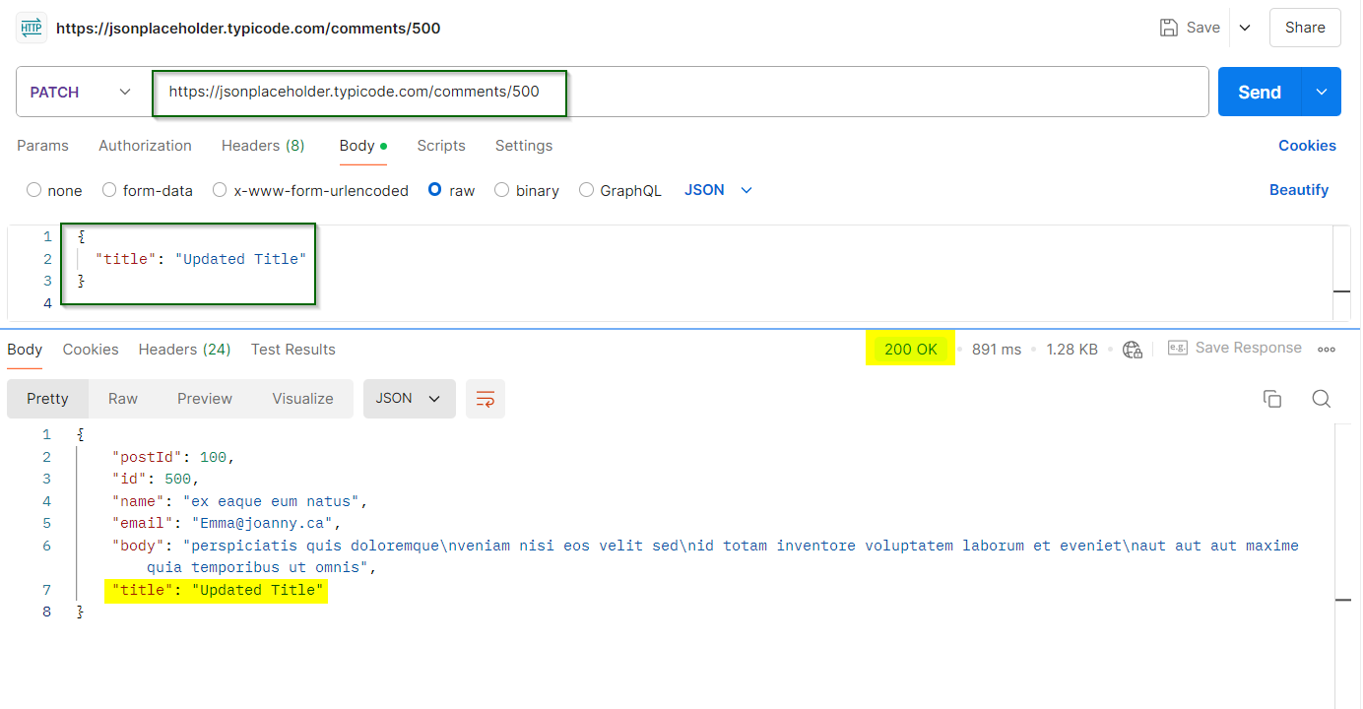

* **Request Type**: PATCH
* **Example URL**: https://jsonplaceholder.typicode.com/albums/21

**Steps:**

* Send a PATCH request with updated data.
* Verify the response status code is 200.
* Verify the response body contains the updated data.

**Payload:**

{

  "title": "Updated Title"

}

* **Request Type**: PATCH
* **Example URL**: https://jsonplaceholder.typicode.com/photos/999

**Steps:**

* Send a PATCH request with updated data.
* Verify the response status code is 200.
* Verify the response body contains the updated data.

**Payload:**

{

  "title": "Updated Title"

}

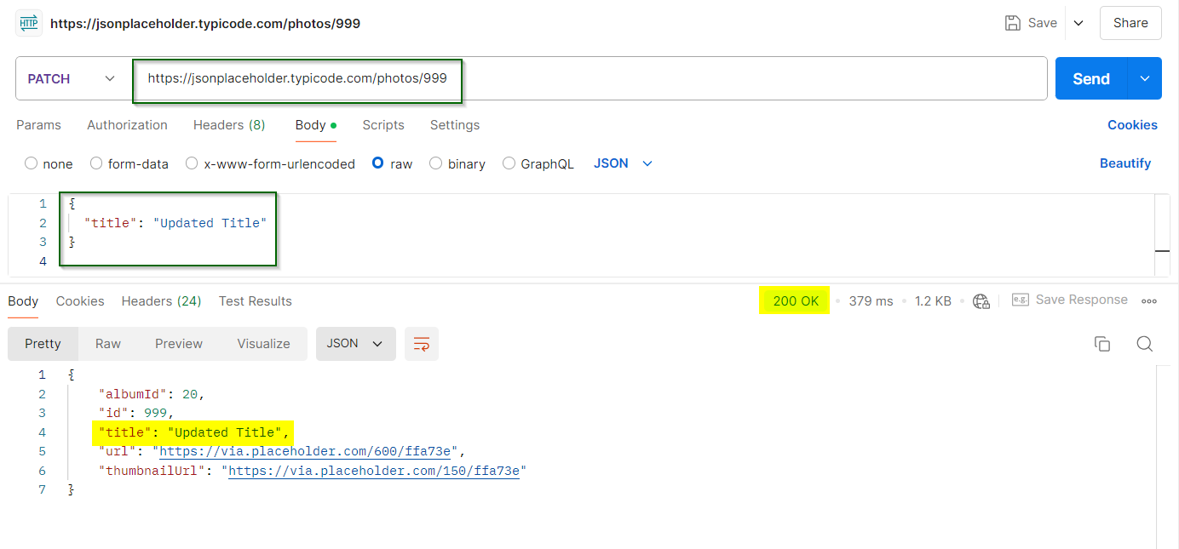

* **Request Type**: PATCH
* **Example URL**: https://jsonplaceholder.typicode.com/todos/100

**Steps:**

* Send a PATCH request with updated data.
* Verify the response status code is 200.
* Verify the response body contains the updated data.

**Payload:**

{

  "title": "Updated Title"

}

* **Request Type**: PATCH
* **Example URL**: https://jsonplaceholder.typicode.com/users/9

**Steps:**

* Send a PATCH request with updated data.
* Verify the response status code is 200.
* Verify the response body contains the updated data.

**Payload:**

{

  "title": "Updated Title"

}

**C. Delete a specific resource (6 marks). Verify the response code. Verify the response body.**

* **Request Type**: DELETE
* **Example URL**: https://jsonplaceholder.typicode.com/posts/1

**Steps:**

* Send a DELETE request to remove the resource.
* Verify the response status code is 200.
* Verify the response body is empty.

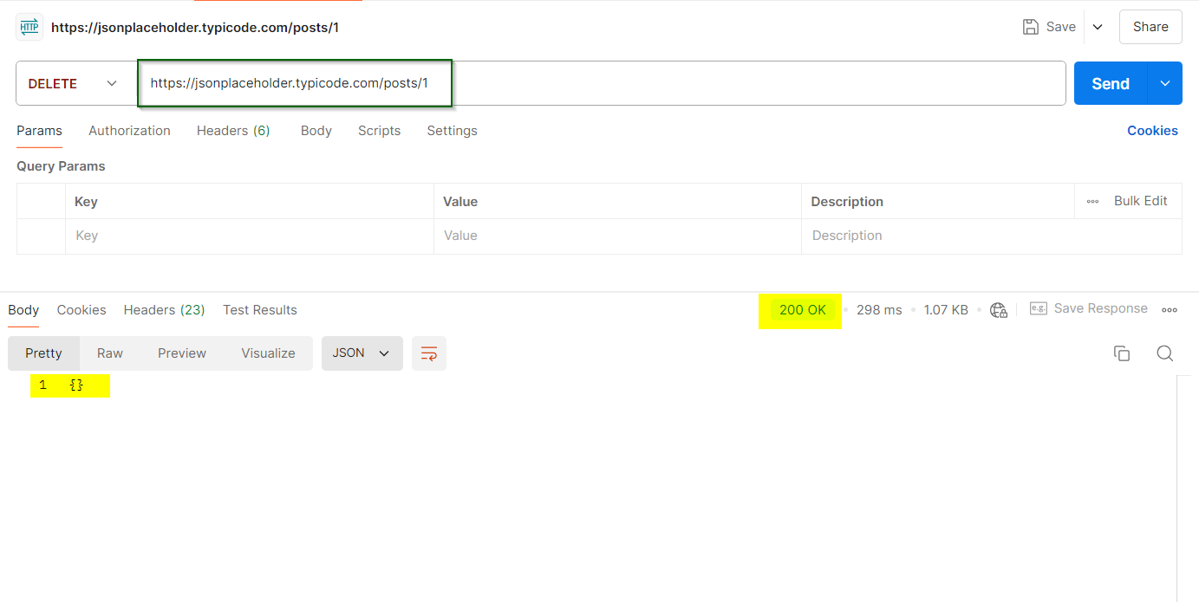

* **Request Type**: DELETE
* **Example URL**: https://jsonplaceholder.typicode.com/comments/500

**Steps:**

* Send a DELETE request to remove the resource.
* Verify the response status code is 200.
* Verify the response body is empty.

* **Request Type**: DELETE
* **Example URL**: https://jsonplaceholder.typicode.com/albums/21

**Steps:**

* Send a DELETE request to remove the resource.
* Verify the response status code is 200.
* Verify the response body is empty.

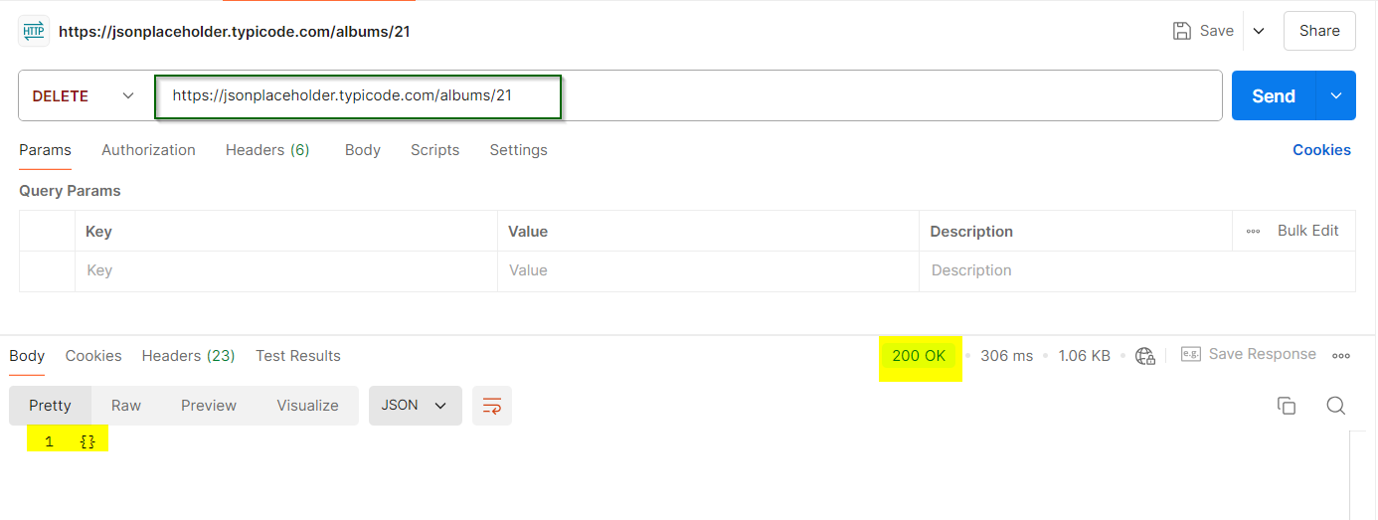

* **Request Type**: DELETE
* **Example URL**: https://jsonplaceholder.typicode.com/photos/999

**Steps:**

* Send a DELETE request to remove the resource.
* Verify the response status code is 200.
* Verify the response body is empty.

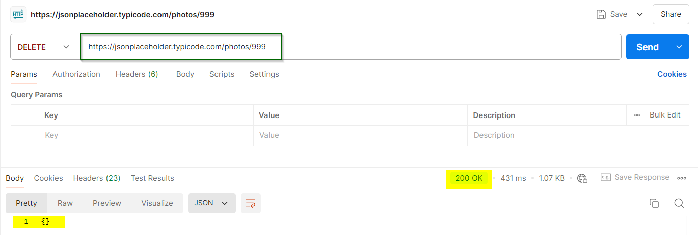

* **Request Type**: DELETE
* **Example URL**: https://jsonplaceholder.typicode.com/todos/100

**Steps:**

* Send a DELETE request to remove the resource.
* Verify the response status code is 200.
* Verify the response body is empty.

* **Request Type**: DELETE
* **Example URL**: https://jsonplaceholder.typicode.com/users/9

**Steps:**

* Send a DELETE request to remove the resource.
* Verify the response status code is 200.
* Verify the response body is empty.

**d. Create your own resource (6 marks). verify the response code. Verify the response body.**

* **Request Type**: POST
* **Example URL**: https://jsonplaceholder.typicode.com/posts

**Steps:**

* Send a POST request with new resource data.
* Verify the response status code is 201.
* Verify the response body contains the newly created resource data, including the assigned id.

**Payload:**

{

  "title": "New Post",

  "body": "This is the body of the new post",

  "userId": 1

}

* **Request Type**: POST
* **Example URL**: https://jsonplaceholder.typicode.com/comments

**Steps:**

* Send a POST request with new resource data.
* Verify the response status code is 201.
* Verify the response body contains the newly created resource data, including the assigned id.

**Payload:**

{

  "title": "New Post",

  "body": "This is the body of the new post",

  "userId": 1

}

* **Request Type**: POST
* **Example URL**: https://jsonplaceholder.typicode.com/albums

**Steps:**

* Send a POST request with new resource data.
* Verify the response status code is 201.
* Verify the response body contains the newly created resource data, including the assigned id.

**Payload:**

{

  "title": "New Post",

  "body": "This is the body of the new post",

  "userId": 1

}

* **Request Type**: POST
* **Example URL**: https://jsonplaceholder.typicode.com/photos

**Steps:**

* Send a POST request with new resource data.
* Verify the response status code is 201.
* Verify the response body contains the newly created resource data, including the assigned id.

**Payload:**

{

  "title": "New Post",

  "body": "This is the body of the new post",

  "userId": 1

}

* **Request Type**: POST
* **Example URL**: https://jsonplaceholder.typicode.com/todos

**Steps:**

* Send a POST request with new resource data.
* Verify the response status code is 201.
* Verify the response body contains the newly created resource data, including the assigned id.

**Payload:**

{

  "title": "New Post",

  "body": "This is the body of the new post",

  "userId": 1

}

* **Request Type**: POST
* **Example URL**: https://jsonplaceholder.typicode.com/users

**Steps:**

* Send a POST request with new resource data.
* Verify the response status code is 201.
* Verify the response body contains the newly created resource data, including the assigned id.

**Payload:**

{

  "title": "New Post",

  "body": "This is the body of the new post",

  "userId": 1

}

